PROJECT REPORT

ON

**Software Development Lifecycle (SDLC) Analysis of Siemen’s Smart Grid Framework**

***A comparative study of various models for the efficient development of Siemen’s Smart Grid Technology***

*Submitted to*

**NMAM Institute of Technology, Nitte**

(Off-Campus Centre, Nitte Deemed to be University, Nitte – 576110, Karnataka, India)

On partial fulfilment of the requirements for the award of the

Degree of Bachelor of Technology

In

INFORMATION SCIENCE AND ENGINEERING

By

***Ankitha***

***NNM23IS015***

Under the guidance of

Dr. Jason Elroy Martis, Associate Professor,  
Department of Information Science and Technology,  
NMAM Institute of Technology, Nitte, Karnataka, India

**Table of Contents**

1. **Introduction 1**
2. **Analysis of SDLC Models 2-14**
   * Incremental Development Model
   * Spiral Model
   * 2.3 Spiral Model
3. **Requirements Engineering Process 15-17**
   * 3.1 Functional Requirements
   * 3.2 Non-functional Requirements
   * 3.3 Requirements Validation Strategy
4. **Conclusion 17**
5. **References 20**

## 

## **Introduction:**

In a universe with dominance by electricity, secure, efficient, intelligent transmission of electric energy has gained increased importance. Old grids, designed for an era of easier energy demands, seem unable to contend with increasing energy demands, monitors' penetrating the grid, and further demands for real-time responses. This Siemens Smart Grid Management System transforms old structures into highly adaptive self-governing networks that improve efficiency, reliability, and sustainability.

Ultimately, this system is, in effect, the brain of the electricity supply network that makes real-time decisions governing power distribution via automation, AI, and real-time analytics. It assesses demand and predicts its changes so energy flow is adjusted accordingly to enhance performance. Rather than fixed schedules and manual intervention in traditional grids, Siemens smart grids are responsive in a dynamic way, balancing surges in demand, integrating solar and wind into the mix, and locating faults before they can become outages.

There lies the beauty of this system in intelligent energy optimization. With the increase in reliance on renewable energy, the variability of power generation has increased; e.g., solar panels work only during the day, while wind turbines operate only when the wind blows. The direct connection of the clean energy sources into the system enables balancing of their inherent variability through automatic load shifting or storage of oversupplied power for use at a later time. This brings dual benefits: a year's reduction in dependence on fossil fuels and reduced costs to both energy suppliers and consumers.

Siemens Smart Grid Management is people-oriented while introducing efficient technologies. With recurrent cyber threats and freak weather, power grid security matters a lot. The unique feature of this system is the inbuilt cybersecurity armor, automated fault detections, and predictive maintenance abilities to always detect, remedy vulnerabilities, and pre-empt failures. There is no other power company in the world whose infrastructure can power machinery with an integrated existing power infrastructure, even with legacy systems.

By adhering to necessary requirements such as grid stability, efficiency, cybersecurity, and resilience, Siemens' smart grid technologies forge a way for a future-ready electricity network. The cornerstone of energy management, this system ensures uninterrupted power supply to our smart cities, seamless electric vehicle charging, and support for industries with significant energy needs. It is this capability that makes power grids smart and at the same time intelligent.

## **1.Incremental Development**

**Flowchart**

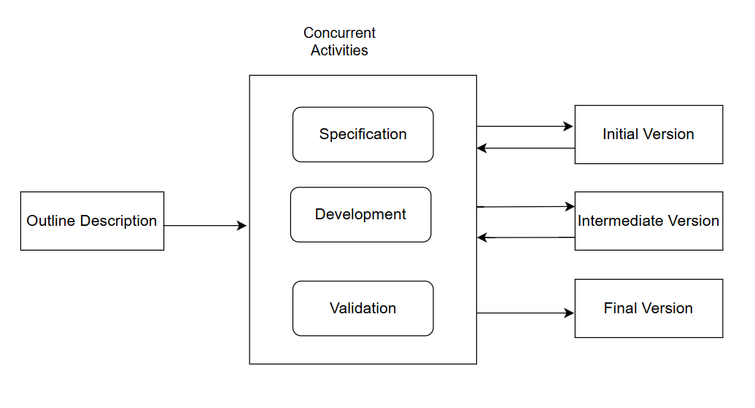

**How Siemen’s Smart Grid Management System uses the Incremental Model**

**Phase 1: Initial Specification and Prototype Development**  
At first, this takes place in the very beginning stages of the development process. The functionality overview of the Smart Grid Management System is built around the major functional requirements. The original specification of how to keep track of the basic features of grid monitoring incorporates real-time monitoring for energy consumption analytics. A rudimentary prototype, limited in what it can accomplish but demonstrating feasibility for the system, is created. To verify that the core components work at least up to the required operational level, some preliminary testing is conducted.  
  
**Phase 2: Responsive Testing and Upgrading**

As soon as the first edition gains validation, several additional features will be added in onward stages. This means that features related to advanced demand-response management, predictive maintenance using AI, and integration of renewable energy sources will be incorporated. Each time through this cycle, the developing software is developed and validated iteratively, with an eye toward ensuring it meets the real-time demands of the developing energy grid and to minimize real-world risks.

**Phase 3: Validation and Integration Testing**

It is very intense testing that is done as each update moves along, performance, security, and compliance within the constraints of selected regulations. Further refinements to the system will come from the smart grid operators' and stakeholders' feedback. The initiation of this phase will ensure seamless interoperability with existing grid infrastructures while also catering to aspects with regards to cyber security to avert unauthorized access attempts. This is the crucial stage; thus, this ensures every release works fine before it goes into the live version.

**Phase 4: The Final Version Deployment and Maintenance**

The process of many iterations results in a finalized version of the Smart Grid Management System prepared for a full-scale deployment. The updated version has fully optimized energy management algorithms, user-friendly dashboards, and automated grid fault detection. After deployment, ongoing maintenance and monitoring help to address the problems that might arise and secure the long-term stability and efficiency of the system. Future enhancements might still be introduced in other incremental updates.

**Functional Requirements:**

**1.Real-time status:** The system should continuously observe and record electricity demand, supply levels, and the overall stability of the electricity network.

**2.Automated Load Adjustment**: Ensure efficient power distribution through automated load balancing to meet fluctuating demand.

**3.Energy Data Insights:** Develop tools to provide/generate a reporting function detailing power consumption pattern over time.

**4.Fault Detection and Alerts:** Implementing a fault detection system that detects the power grid failures and immediately notify relevant operators.

**5.Authorized Access:** Ensure the system can only be accessed by authenticated administrators and grid operators using secure login procedures**.**

**6.Remote grid control:** Implement a remote grid control system that controls the power grid, including stitching, rerouting and load management functions.

**Non-Functional Requirements:**

**1.Self-Healing Mechanism:** The system needs toimplement an autonomous self-healing mechanism that allows the grid to automatically detect, isolate, and recover from faults without manual intervention to ensure continuous service.

**2.** **Optimized Energy Transmission:** To ensure efficient power delivery and minimize wastage, design the architecture such that it optimizes and reduce transmission and conversion losses.

**3.** **Dynamic Load Adaptation:** Develop a system that dynamically adjusts power distribution, prioritizing critical infrastructure during peak demand or failures. This approach enhances grid stability and safeguards against dynamic load-altering attacks, minimizing the potential damage.

**4.** **Seamless Cross-Platform Integration:** Ensure seamless cross-platform integration, allowing the system to integrate effortlessly with third-party energy providers, IoT devices, and legacy power management tools, eliminating compatibility issues.

**5.** **User-Centric Customization:** Implement personalized dashboards, alerts, and controls for operators adapted to specific grid zones and individual operational needs to ensure user-centric customization.

**6.** **AI-Driven Predictive Maintenance:** Use AI and machine learning to proactively predict failures in transformers, power lines, and substations, preventing unexpected breakdowns through AI-driven predictive maintenance

**Risk Management:**

**1.System Integration Complexities:** To ensure seamless integration and minimize potential disruptions, comprehensive testing should be performed on each incremental release with the existing systems.

**2.Scalability Issues:** Future increments may face challenges in scaling to meet evolving grid demands, the increasing influx of data from smart meters, and the growing integration of distributed energy resources (DERs). As Siemens spreads its frameworks, scalability becomes crucial.

**3.Securiy Risk Assessment:** Gradual development may leave partially implemented features exposed to cyber threats, increasing the risk of unauthorized access, data breaches, or system manipulation. Since security measures are often integrated progressively, attackers may exploit vulnerabilities in early increments before full security protocols are enforced across the system.

**4.Data Inconsistencies:**  Since the system processes real-time electricity demand, supply levels, and fault detection data, inconsistencies may arise when new increments are added to existing modules. If data synchronization is not carefully managed, outdated information may lead to incorrect grid adjustments, misreporting, or delays in fault detection.

**5.Technical debt:** Rapid development in increments may lead to temporary fixes or shortcuts in system design, which can make future scalability and maintenance more complex. If not managed properly, these compromises can increase long-term costs and complexity when upgrading or maintaining the system.

**Change Management:**

**1.Proactive Risk Assessment:** Identifying and mitigating risks early prevents disruptions before they impact the grid. This ensures smooth integration of changes without compromising stability, security, or performance.

**2.** **Automated Deployment & Testing (CI/CD):** Using automated testing and deployment pipelines reduces manual errors, speeds up development, and ensures each update is secure, reliable, and fully functional before implementation.

**3.** **Stakeholder** **Feedback Loop:** Continuous collaboration with energy providers, regulators, and users helps refine system functionalities, improving efficiency and ensuring that evolving needs are met.

**4.Change Impact Analysis:** Assessing how updates affect the existing infrastructure prevents performance bottlenecks, compatibility issues, and system failures, ensuring seamless transitions.

**5.Phased Rollouts with A/B Testing:** Deploying updates in phases to select zones allows for controlled monitoring and refinement before full implementation, reducing risks and optimizing performance.

**Time Constraints:**

**1.Regulatory Compliance Delays:** The strict regulations in the energy sector requires approvals for security, environmental impact and operational changes. These regulations may not align with the project’s incremental pace, which causes delays before certain features are implemented.

**2.Live System Synchronization:** Since the smart grids demand continuous operation, making updates challenging without disrupting power supply, deployments or the changes must be strategically scheduled during off-peak hours to minimize instability power distribution and ensure grid stability.

**3.Cross-Team Coordination challenges:** Smart grid project will be having different teams working on various increments simultaneously, and inconsistencies in scheduling or communication can create barriers, leading to significant project delays and increased costs.

**4.Ongoing Quality Assurance:** Unlike Waterfall, where testing happens once at the end, incremental development requires continuous validation of each new feature and its alignment with existing components. This cumulative testing effort increases overall project time and resource requirements.

**Cost Constraints:**

**1.Specialized Workforce Retention:** Smart grid projects require professionals who are expert in AI, cybersecurity, and power systems, throughout the project lifecycle. Retaining these skilled professionals for long term increases labor costs substantially.

**2.Deployment Transition Costs:** Transitioning between increments require resources for data migration, system validation and performance monitoring. And these transition costs will be added to the overall project expenditure.

**3.Sustained Operational Expenses:** Each new increment increases system complexity, requiring regular security updates, bug resolutions, and continuous performance monitoring. Over time, these ongoing maintenance efforts accumulate, increasing the overall cost of system ownership.

**4.Scalability Expenses:** As the system expands, infrastructure upgrades such as cloud storage enhancements and enhanced data processing capabilities becomes more essential. These scaling and expansion costs can result in unexpected financial expenses, particularly with increasing data volumes.

## **2.Waterfall Model**

**Flowchart**

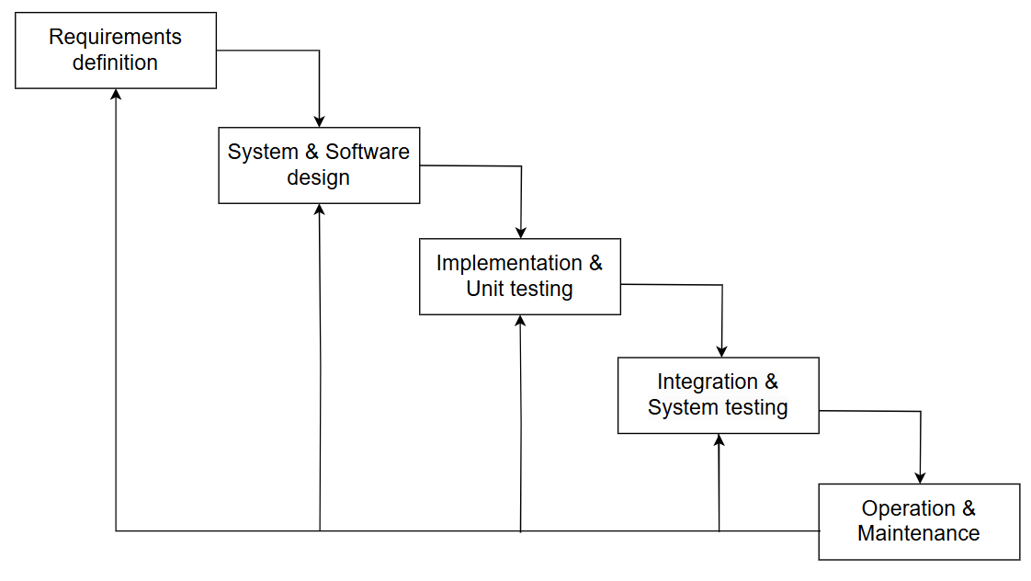

**Phase 1: Requirement Definitions** The first phase is concerned with the compilation of Siemens' Smart Grid Management System's functional and non-functional requirements into a written document. This phase covers features for grid monitoring, analytics for power distribution, cybersecurity measures, and requirements for system scaling. As the Waterfall model is a linear approach, any changes after this phase will trigger massive rework. Thus, requirements have to be considered in a complete and correct format prior to the commencement of the project.  
  
**Phase 2: System & Software Design** After the requirements are finalized, the architecture and software design are followed. The system is in the process of being modularized for real-time power monitoring, load balancing, and fault detection. The software components are described further for compatibility with the existing infrastructure and adherence to regulatory obligations. At this stage, Siemens is expected to have built a very strong system design that can support long-term operational needs with minimal modifications required.  
  
**Phase 3: Implementation & Unit Testing** The developer shall code the system according to the specified system requirements based on the guidelines from the architect. Energy forecasting tools, automated grid control, and other modules will be part of this implementation. Unit testing shall internally self-verify a certain module of the program through tests conducted entirely within itself; this allows for errors to be found late in module development to be easily identified and corrected. Since this is a strictly sequential procedure, integration is not going to happen at this level; instead, it will be invoked via isolated unit testing to test the individual modules extracted from each component.

**Phase 4: Integration and System Testing** After the modules are developed and tested, they are brought together to form a working system. The integration process for testing component interaction for fast data exchange among grid sensors, control units, and cloud analytics is large-scale. System testing will uncover most bottlenecks and examine the potential of system integration into one live system."   
  
**Phase 5: Operation and Maintenance** Once the Smart Grid Management System has passed its tests, it is put into operation and use. In this phase of operations, continuous monitoring for fault detection and inefficient utilization is done, whereby maintenance teams are on alert to troubleshoot and offer potential software and installations. The Waterfall model does not entertain ongoing iterations: any upgrades or changes in the future will be through structured maintenance or perhaps a newly launched life cycle for primary system changes.

**Functional Requirements:**

**1.Strategic Capacity Planning:** The system should support long-term infrastructure planning by analyzing how much power we have used and and how much we think we will need. This helps for the future power station placements and how to improve the grid.

**2.Automated Compliance Verification:** The system should automatically check to make sure that every update and operational changes follows all the national and international rules. This prevents legal complications and ensures the system is always certified.

**3.Secure Transactional Data Storage:** The system should store all the data about the energy use, billing and grid changes in a super-safe database that can’t be. This helps energy companies bill accurately and catch fraud.

**4.Centarlized Outage Management System:** The system should provide a centralized dashboard for tracking, reporting and fix power outages in all the parts of the grid.This helps us to solve the problem faster and prevents interruption of prolonged service.

**5.Hierarchial User Permission Management:** The system should have strict access controls for operators, regulators and maintenance personnel. This ensures that only certain people should be able to change important grid settings.

**Non-Functional Requirements:**

**1.Predictable System Performance:** The system should always respond quickly, even under peak electricity load conditions. This ensures reliability, as grid operators need to be able to rely on timely data to make decisions.

**2.Extended Operational Lifespan:** Since we update the system only after it is fully deployed, the architecture should be designed in such a way that it should remain stable over for long time. This reduces the interruptions caused by frequent patches or redesigns.

**3.Rapid Historical Data Access:** The system should be able to find the old grid data with minimal delay, regardless of how big the database is. This helps grid analysts to make decisions faster based on the past information.

**4.Strict Compliance-Driven Security:** The security for the system should be planned from the beginning itself to avoid any cyber threats, ensuring no security patches has to be added later on.

**5.High-Redundancy Backup Mechanism:** The system should have multiple layers of backup storage of the grid settings and operational records. This prevents problems when we accidently lose data or get attacked by hackers.

**Risk and Change Management:**

**1.Late-Phase Risk detection Cost Amplification:** Since risks are not identified until late in the entire process, critical issues with the system’s security or how it responds to grid issues may be not be visible until the last testing. Fixing these problems at last stage requires more time and even costs more.

**2.Regulatory Adaption Inflexibility Cost Burden:** Since the waterfall model is so linear, if we miss out any energy rules while building the system, then we will have to do entire thing from the beginning. This lack of the flexibility will make this system to consume more time and expensive, especially in the energy sector where policies are more frequently used.

**3.Runtime Fault Correction System Disruption:** Errors which are found out after deploying or while the system is already running, like load balancing or fault detection, then we have to correct entire development system form the beginning. This makes error correction slow and expensive.

**4.Requirement Specification Deficiencies Project Impact:** If we do any mistakes with the power distribution needs at the beginning then the system may not work well in the real world. Because we can’t make any changes during mid of the development system, correcting these mistakes will take a lot of time and cost.

**Time and Cost Constraints:**

**1.Linear workflow: Schedule Proliferation:** Because each step must be fully completed before we go to the next step, the whole process takes a long time.If we cause dealys in the early phase itself then we will take a lot of time just to detect and correct it,which then cause problems down the line and make the project to take a longer time.

**2.High Upfront Costs with limited early costs:** Since we have to build the sytem before we actually start using it, then it requires a lot of money without any actual benefits then.This makes it very risky like if we have to make more costly changes after the system is deployed.

**3.Dedicated Team Structure-Limited Adaptability:** Teams will have to work on their assigned tasks throughout the whole project. If new technology comes out while we are working on the project, adapting them would make our project extra time and cost.

## **3.Spiral Model**

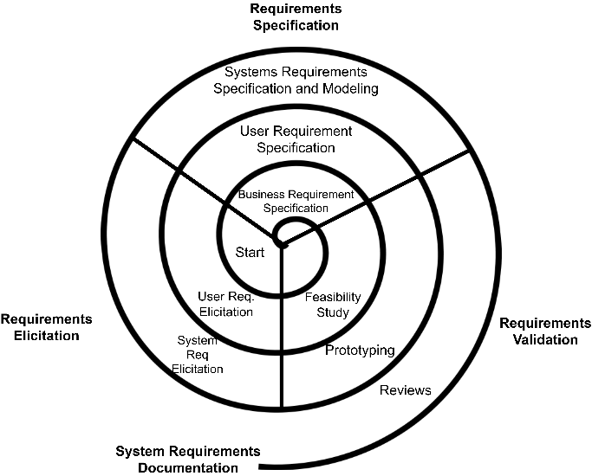**Flowchart**

## 

**Phase 1: Risks Analysis and Prototype**

Before rolling out critical features such as AI-based grid load optimization, Siemens carries out an extensive risk analysis. It notices power failure risks, cyber vulnerabilities, and compliance with energy regulations. In the Spiral Model, instead of building the entire system all at once, it builds small-scale prototypes of features such as automated outage detection and tests them in controlled simulation environments before continuing on.

**Phase 2: Concept Validation and Refinement**

**Once the prototypes are tested, Siemens aggregates performance data and available expert** opinion to modify the originally conceived system. This phase is repeated several times to ensure stability and efficiency on the grid. Forecasting algorithms, energy distribution models, and real-time monitoring systems are corrected to align with the operational and business goals before developing them fully.

**Phase 3: Development and Testing in Iteration**

Each component-daily demand forecasting, fault detection, and automated recovery-is built and tested in repeated iterations. The development team improves system functions based on the risk assessments and the early feedback of energy providers and operatives. Controlled simulations fitted with pilot implementations in selected areas support everybody in functional validation before further scaling up.

**Phase 4: Wider Validation and Security Test**

The major concerns for smart grids are security and stability. The system goes through extensive testing at this stage for cyber resiliency, in-the-moment fault tolerance, and compliance to international energy regulations. These are evaluated further, vulnerabilities ironed out-one step in the direction of larger, grid-enabling system-rollouts.

**Phase 5: Gradual deployment and performance monitoring**

The validated system is rolled out in phases in small pockets or controlled trial cities before large-scale deployment. Live performance data on the parameters such as precision of load balancing, correction time for faults, and energy efficiency is systematically monitored. Any detected undesirable occurrences trigger some refinements before the final rollout.

**Phase 6: Refinement and Continuous Improvement**  
Now that the system has gone live, Siemens is continuously improving with AI-enabled analytics, predictive maintenance, and real-time user feedback. The Spiral Model continuously evaluates risks and promotes enhancements allowing the smart grid to answer shifts in demand of energy, change in regulations, and leverage technological advancements- all while maintaining reliability.  
  
This methodology makes sure that the Smart Grid Management System is scalable, safe, adaptive, and further adopts a risk-averse policy in all levels of development.

**Functional Requirements:**

**1.Advanced Load Forecasting:** This system learns from real-time and historical data to predict the electricity demand fluctuations properly. This helps us to balance the load on the grid and prevents any shortages of the power.

**2.Adaptive Cybersecurity Protocols:** Security mechanisms should progress with each development cycle, learn about the new threats and use AI to spot anything suspicious. This ensures that grid is safe from the hackers.

**3.Power Grid with Built-In Redundancy**: This system is built with backups on backups. Because if one thing fails, there are other layers which will be ready to cover that failed one. This prevents small problems from growing into large, widespread outages.

**4.Intelligent Grid Restoration**: This system should enable automated decision-making such that it can restore power after failures by prioritizing critical services. If there’s a power outage, this system can think for itself and get the lights back on quickly. Using AI-based self-recovery, it should apply rerouting technique to reduce service interruption.

**5.Grid-Specific Customization for different locations:** The system should adjust to region-specific grid structures. It considers local energy policies and resources to make sure that the power is available efficiently across different regions.

**Non-Functional Requirements:**

**1.Performance-Optimized Scalability:** The system should support scalability, allowing to add more power stations, renewable energy and storage without effecting the performance. This ensures that grid stays efficient, even if it gets bigger.

**2.Iterative Risk Management:** At every stage of development, the system should implement potential problems and figure out how to fix them. This ensures that the system remains effective for a long-term use and can catch issues before they cause real trouble.

**3.Adaptive Data Optimization:** Th system must be able to react to real-time load conditions that maximizes the rate of data processing. Adaptive communication protocols and intelligent caching must minimize latency at high load.

**4.Auotmated System Diagnostics**: The system regularly checks its own performance to ensure its efficiency, fault tolerance and response times. This helps us to maintain consistent service levels.

**5.Modular Technology Upgradability:** The system should be able to upgrade to newer hardware and software components without causing any interruptions. All the modules should be designed to be replacable or upgradable as technology improves.

**Risk and Change Management:**

**1.Adaptive Architecture for Threat Mitigation:** Since the energy grid evolves with external factors like climate changes and cyberattacks, we check for risks at every step. This helps us to make system’s design stay flexible and enhance long-term adaptability.

**2.Technical Debt Mitigation Strategy:** For each iteration as we add new features, maintenance challenges increases. Therefore a structured plan ensures older parts are updated or replaced before they cause problems in system’s efficiency.

**3.Agile User Feedback Integration:** Every time we make any changes we get the feedback from energy providers, regulators and grid operators to refine the functionalities. This helps us to ensure that the system works best in real-world situations and meet everyone’s needs.

**4.Dynamic Compliance Alignment:** The rules for the energy industry change frequently, requiring continuous adaption. By checking compliance at every stage, the system remains aligned with industry policies and avoid any disruptions.

**Time and Cost Constraints:**

**1.Iterative Risk Assessment Increasing Time and Cost:** Since each development cycle requires in-depth risk evaluation, including cyberattacks and making sure that the grid is stable and follows the rules, it can extend the timelines and cost more. We need to invest in tools and experts to manage these risks properly.

**2.Prototyping and Refinement Overheads:** Unlike other models, the Spiral approach demands repeated test and validation leading to more use of resources and making things more expensive, requiring advanced simulation tools to simulate everything.

**3. Interdepartmental Dependency Schedule Variance:** Frequent collaboration between AL specialists, cybersecurity experts, grid operators and regulators makes it complicated to keep everyone on the same page. And if the schedules are not properly aligned then it will increase expenses and cause delays.

**4.** **Regulatory Approval Lag Cost Escalation:** Every phase must meet strict energy regulations and security standards, usually needing to be approved separately for each stage. These delays not only extend the project deadlines but also increase legal costs, which makes it difficult to predict the budget.

## **Requirements Engineering Process**

**Functional Requirements:**

**1.Automated Demand Response:** Application of AI-real time demand-responsiveness that calculates energy distribution according to grid load flow and consumer demand variations.

**2.Grid Resilience and Blackout Prevention:** An automated contingency system that identifies the point of blackout under different extreme conditions and responds by either re-routing power flow from extensive distributions or switching off non-critical loads temporarily.

**3.Renewable Energy Forecasting:** Use predictive machine learning models to predict solar and wind energy output by using weather patterns to develop better optimization for grid integration of renewable resources.

**4.Distributed Energy Storage Optimization:** An efficiently managed BESS redistributes stored power given the system peak demand and economy to deliver a reduction in energy waste and stabilizes the grid.

**Non-Functional Requirements:**

**1.Latent optimization for Real-Time Control:** Ultra-low latency for critical grid operations: fault localization, automated switch operation (<100ms response time), other operations.

**2.Edge computing for decentralized processing:** Use of edge computing reduces dependence on cloud-based operations while processing local grid data in real time for better speed and reliability.

**3.Sustainable use and carbon footprint monitoring**: Incorporate systems to track real-time emission levels for grid operators and for consumers to foster sustainable energy consumption practices.

**4.Self-healing mechanisms based on AI models:** Enable an AI-driven solution involving fault detection, isolation, and self-correction within the electrical grid without human intervention for the establishment of consistent power integrity.

**Requirements Validation Strategy**

All functional and non-functional requirements must match operational requirements. Various techniques are used to achieve and confirm requirements validation so that the system works as intended.

**1.Stakeholder Reviews:** Here, electricity grid operators, engineers, and regulators agencies worked side by side to ensure that all functional requirements match actual operational needs and regulatory standards.

**2.Simulation & Load Testing:** One legitimate way of validating the performance of a system is to do simulation on maximum load scenarios by varying the power demand.

**3.Automated Testing & Real-Time Monitoring**: Usage of continuous integration and automated testing minimizes the risk of the bulk power systems becoming non-operational or decreasing reliability because of bulk power systems' non-confirmation to grid reliability standards.

**4.Cybersecurity Audits:** The regular vulnerability assessment and penetration testing on the system are sufficient enough for strengthening it against certain threats that may arise from cybercrimes, leading to security for energy distribution in general.

**5.Adaptive User Feedback Systems:** The utility providers and their customers provide feedback using adaptive user systems that may help improve the responsiveness of the system toward real-time energy demands and efficiency metrics.

**Challenges in Requirements Validation**

There are some challenges that the validation approach for Siemens Smart Grid Management System encounters. Complexity of Compliance with Regulations: It is a great challenge being compliant with different regional and international energy regulations while still being compliant with those standards.

**1.Dynamic Scaling for Load Management:** The system affords the power grid to continue functioning without fast-overload failure through its capability to handle unexpected events that impact power load.

**2.Data Accuracy & Latency:** Real-time data processing is undoubtedly critical; otherwise, if it comes too late or is inaccurate, operations become labor and time inefficient.

**3.Cybersecurity Threats:** It is an evergreen challenge to strengthen the cybersecurity of the grid as the level of threat from cyberattacks on critical infrastructure always rises further.

**4.Integration with Legacy Systems:** One technical challenge that many energies providers face is integration of a modern grid management solution into archaic infrastructure.

## **Conclusion:**

Siemens announces its grid management system. This new production incorporates automation, AI, and a real-time analytics platform that aims to enhance efficiency, reliability, and sustainability when it comes to efficient power distribution. In some context for the software development efficiency, it has done substantial abstraction-Again, consideration of the definitions of models, according to its testing approach-waterfall spiral, and iterative model-should be based on their suitability towards either of the strategies of the most resilient, scalable, and secure smart grid systems.

* In many ways it clarifies that: - The Incremental Model allows for iterative development of features such as predictive maintenance, renewable energy forecasting.
* The Spiral Model allows for risk control and constant improvement intended for dealing with cybersecurity threats and regulatory compliance challenges.
* The Waterfall Model takes its time to roll out but can as well work to establish high-level requirements even before deployment.

Meanwhile, requirements engineering pertains to tailoring and verifies that functional and non-functional requirements are satisfied, taking into account the proposed operational, security, and scalability guidelines. Other challenges include regulatory complexity, data latency, cyber security risks, and interoperability with legacy systems.

## **References:**

1. <https://www.renewableenergyworld.com/power-grid/smart-grids/siemens-rolls-out-distribution-management-system-for-smart-grids/>

2. Sommerville, I. (2015) Software Engineering (10th edition). Pearson.

3.Wikipedia- <https://en.wikipedia.org/wiki/Electric_power_system>